TO DO LIST REPORT

Project 1

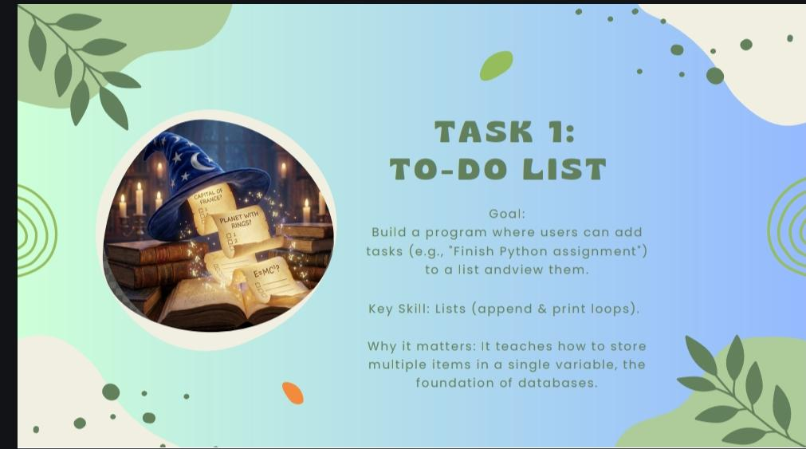

Submitted by: Rhytham Audichya

Organization: Decode Labs

Declaration
I hereby declare that the project titled "To-Do List Management System Using Python" submitted as part of my internship at Decode Labs is an original work carried out by me. The project has been developed under the guidelines provided during the internship program.

Acknowledgement
I would like to express my sincere gratitude to Decode Labs for providing me with the opportunity to undertake this internship project. This project has helped me enhance my understanding of Python programming, data management using lists, and basic application development.
I am thankful to the mentors and coordinators of Decode Labs for their valuable guidance, support, and encouragement throughout the project. Their insights and suggestions helped me successfully complete this work.
Key learning from this project include:
- Understanding the use of Python Lists for storing and managing data.
- Learning how to take user input and process it efficiently.
- Implementing conditional statements (if-else) to control program flow.
- Using loops to display and manage multiple tasks.
- Understanding the concept of data storage in memory.
- Improving problem-solving and logical thinking skills.
- Learning how to structure a simple Python application.
- Gaining experience in debugging and handling invalid user inputs.
- Understanding the importance of user-friendly menu-driven programs.
- Learning how software can be used to organize and manage daily activities.

Table of contents

- Introduction
- Objective
- Problem Statement
- System Requirements
- Technologies used
- Algorithm
- Python code
- Sample Output
- Features
- Advantages
- Future Enhancement
- How to run the project
- Conclusion

1. Introduction
The To-Do List Management System is a simple Python-based application developed to help users manage their daily tasks efficiently. The application allows users to add tasks, view all tasks, and organize their work in a structured manner.
This project demonstrates the use of Python Lists, loops, conditional statements, and user input handling. It serves as a foundation for understanding data management before moving toward advanced database systems.

2. Objective
The main objectives of this project are:
- To understand Python Lists.
- To learn how data can be stored in memory.
- To practice user input handling.
- To implement basic CRUD-like operations.
- To improve logical thinking and programming skills.

3. Problem Statement
People often forget their daily tasks and activities. Managing tasks manually can be difficult and inefficient. Therefore, a digital To-Do List system is required that allows users to store and view tasks easily.

4. System Requirements
Software Requirements
- Python 3.x
- VS Code / PyCharm / IDLE
- Windows, Linux, or macOS
Hardware Requirement

- Computer/Laptop
- Minimum 4 GB RAM
- Intel i3 Processor or higher

5.Technologies used
Python
Python is a high-level programming language used to develop this application.
Lists
Lists are used to store multiple tasks in a single variable.
Loops
Loops help display all stored tasks one by one.
Conditional Statements
Conditions help control the program flow based on user choices.

6. Working of the Project
The project follows the IPO (Input-Process-Output) model.
Input
The user enters a task.
Process
The task is stored in a Python List.
Output
The application displays all saved tasks

7. Algorithm
- Start the program.
- Create an empty list named tasks.
- Display menu options.
- Take user choice.
- If choice is Add Task:
  - Input task name.
  - Store task using append().
- If choice is View Tasks:
  - Display all tasks using a loop.
- If choice is Exit:
  - Stop the program.
- End.

8.Python Code

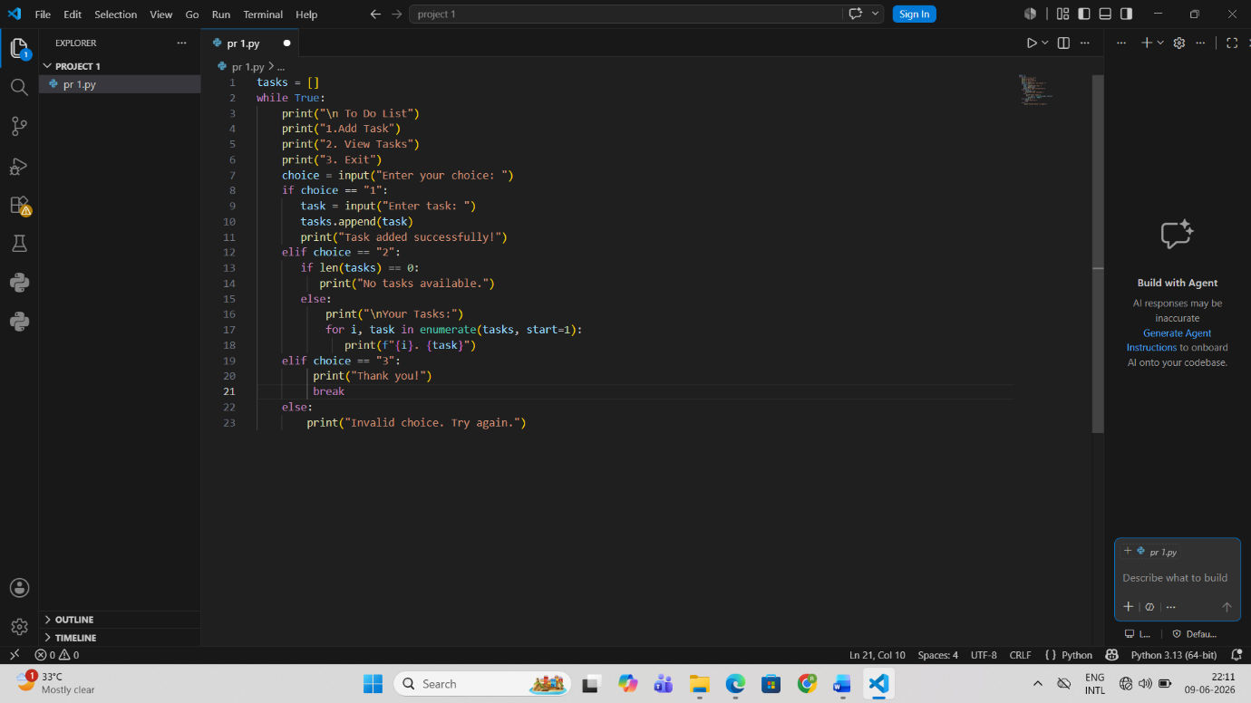

9.Sample Output

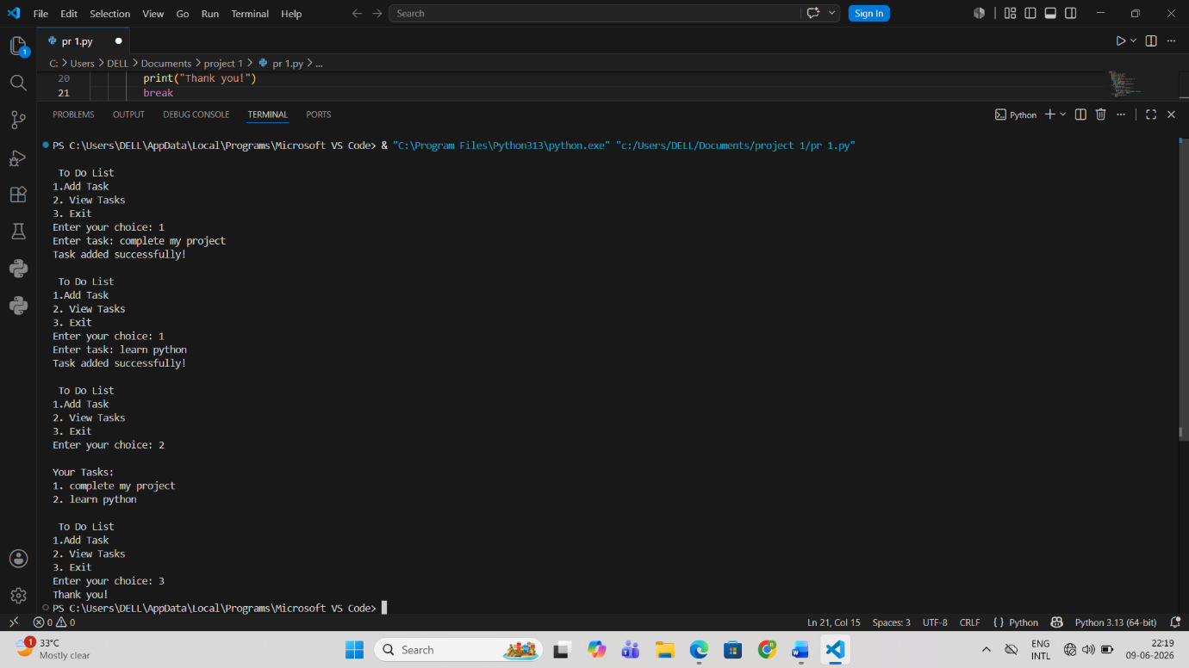

10.Features
- Add new tasks.
- View all tasks.
- User-friendly menu.
- Simple and lightweight.
- Easy to understand and modify

11. Advantages
- Improves task management.
- Easy to use.
- Beginner-friendly.
- Demonstrates practical use of Python Lists.
- Helps understand data storage concepts.

12. Future Enhancements
- Save tasks in a file.
- Add task deletion functionality.
- Add task completion status.
- Use a database for permanent storage.
- Create a graphical user interface (GUI).

13. Conclusion
The To-Do List Management System successfully demonstrates the implementation of Python Lists and basic programming concepts. The project provides hands-on experience with data storage, loops, conditions, and user interaction. It forms a strong foundation for learning advanced backend development and database management systems in future projects.

